**“ List of Economic Factors Affecting Housing Market “**

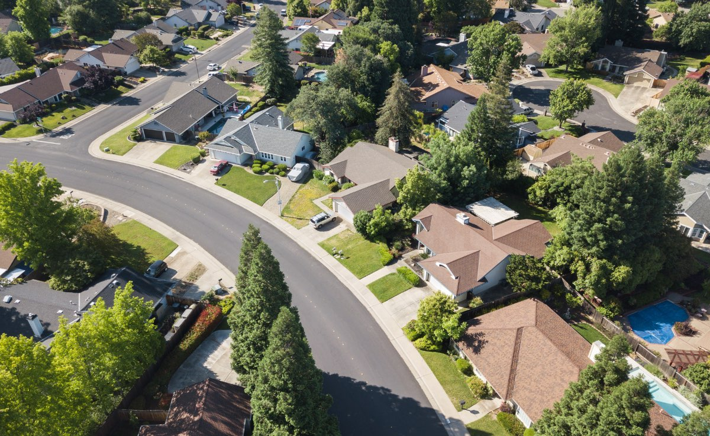

**\* Important Economic Factors Affecting the Housing**

**Market.**

**The housing market is affected by economic status, interest rates, real income, and population density changes. In contrast to these market-side considerations, the available inventory can decide house prices. For cycles of rising demand and limited supply, house prices will go up, rents will rise, and the threat of insecurity will increase.**

**It is the state of the economy, interest rates, actual revenues and shifts in the population, which influences the housing markets. Appropriate prices are determined by the offer available as well as these demand-side factors. There are many builders in Calicut that provide the best homes in all safe manner. In periods of increased demand and limited supply, house prices, rent increases and a higher risk of homelessness can be observed. Let’s discuss what are the economic factors affecting the housing market.**

**1 List of Economic Factors Affecting Housing Market**

**1.1 1. Growth in the Economy:**

**1.2 2. Unemployment:**

**1.3 3. Interest Rates:**

**1.4 4. Customer Trust:**

**1.5 5. Mortgage Availability:**

**1.6 6. Offering:**

**1.7 7. Effectiveness/House Income Rates:**

**1.8 8. Home Sales Economy Mirror**

**1.9 9. Sales of Household Cash Supply**

**1.10 10. Closing Reflects a Market Crash**

**1.11 11. Home Sales Financial Slowdown**

**2 Other Areas and Real Estate Development**

**3 Demographic Factors**

**3.1 Factors that have Long-Term Effects on Housing Supply:**

**3.2 Unusual Factors Affecting the Demand for Property in India, including:**

**4 Economic Factors Influencing the Quality of a License Test**

**4.1 1. Advance**

**4.2 2. Balance**

**4.3 3. Compliance**

**4.4 4. Change**

**4.5 5. Competition**

**4.6 6. Extinct**

**4.7 7. Return Increases and Decreases**

**4.8 8. Surplus Productivity**

**List of Economic Factors Affecting Housing Market**

**1. Growth in the Economy:**

**Housing demand depends on revenue. With higher economic growth and growing wages, people can spend more on housing, improving application and boosting prices. In reality, housing demand is often seen as elastic in terms of income , leading to an increase in revenues for households. In a recession, reduced sales will also stop people from buying, and people who are losing their jobs will fall behind their mortgage payments and end up in their homes repossessed.**

**2. Unemployment:**

**The second important point that comes under the economic factors affecting the housing market is related to economic growth. Very few people will have possible to afford a house as unemployment rises. But even fear of unemployment can stop people from entering the real estate market.**

**3. Interest Rates:**

**Interest Rates**

**Interest rates influence the monthly payment value for mortgages. A high-interest rate era would increase mortgage costs and reduce the demand for a house to be purchased. In contrast to renting, high-interest rates make rental attractive. Homeowners with high adjustable mortgage rates have a more significant effect.**

**4. Customer Trust:**

**Confidence is an essential part when people are to take the risk of taking out a mortgage. Mainly house market expectations are significant. When people fear house prices will decrease, people will postpone purchasing.**

**5. Mortgage Availability:**

**Mortgage Availability**

**Most banks are keen to lend mortgages during the boom years of 1996-2006. It enabled people to borrow large amounts of revenue (for example, five times the income). Additionally, minimal deposits that are 100% of mortgages are provided by banks. The flexibility of hypothecating meant that the housing demand grew as more people could buy now. Yet banks and construction companies have had trouble raising money to finance the financial markets since the 2007 credit crunch. Therefore, their borrowing conditions for a larger house purchase deposit have been improved. The supply of loans has been limited, and demand fell. Get some property documents required for home loan.**

**6. Offering:**

**A supply shortage drives prices up. Over-supply could lead to a fall in prices.**

**7. Effectiveness/House Income Rates:**

**House Income Rates**

**The price-to-earnings ratio impacts demand. For house prices rising about wages, you would expect fewer people to afford. For example, the house price-to-income ratio increased to 5 in 2007. Homes were relatively expensive at this level, and we saw a correction with the drop in house prices.**

**8. Home Sales Economy Mirror**

**Home sales are usually directly related to the stability of an economy and economic growth and decrease. When the economic growth slowdown, cash supplies get limited thoroughly. Because capital is difficult to buy, the housing market will be less available to home buyers. Housing inventories increase and take longer to sell, as stringent credit standards make fewer buyers available. A higher consumer supply combined with lower demand usually leads to lower prices. Also, read about the real estate trends in Kerala.**

**9. Sales of Household Cash Supply**

**Sales of Household Cash Supply**

**The supply of money is vital to its overall health, and in general, for the sustainability of the housing market. The availability of funds in an economy that too when money is hard to receive, sales of home will dry up. Once cash is also easy to buy, too many investors enter the housing market and price rises for some time until the inevitable market correction or even crash happens. Home buildings and home sales should ideally align with economic activities, but this is not the case sometimes. Also read about the real estate portals.**

**10. Closing Reflects a Market Crash**

**Across different economies, housing markets operate differently. The housing market is usually healthy during a strong economy. Then fewer people buy as interest rates rise. There may be an increase in foreclosures when people default on their loans, which usually happens with adjustable mortgages when the prices rise.**

**11. Home Sales Financial Slowdown**

**After an economy slows, the housing markets can be impacted. Slowdowns in the economy impact housing markets as housing-related activity decreases and overall economic demand slows. When economic reforms start and housing prices reflect the willingness of consumers to pay, the economic cycle breaks down.**

**Other Areas and Real Estate Development**

**It can be said that the Real estate market in India will grow based on our speculations. So many factors motivate the buyer of India. The first time, home-seekers will be the general and once adequately regulated, we can certainly take advantage of the factors and participate in India’s economy. It is also true to say that it will only allow other sectors to expand if it is appropriately regulated.**

**Retail firms are also profoundly affected by the increased demand for property markets, such as housing, cement, finance companies. Also, there is a significant difference in pricing between rural India and Urban India. The lack of jobs in rural areas was also of considerable importance. Increasingly more people are moving to cities, engaging in increasing housing requirements and other real estate requirements.**

**The government of India should invest heavily in creating rural employability. Attractive housing schemes can also help generate higher demands. Low bank interest rates and adverse economic conditions can too deter some prospective buyers. You can also increase the supply to reduce the cost of smarter games. Checkout some of the best ways to increase home value**

**Demographic Factors**

**Apart from the economic factors affecting housing market, there are some demographic factors too. The number of households in India. has grown, and there are also more individuals living alone. Some of the reasons for increased house demand in India are:**

**Life expectancy increased for the elderly**

**Divorce rates rise**

**As per now, children leave their homes in early years itself**

**Increase in Marriages**

**They are dreaming to be more Independent.**

**Factors that have Long-Term Effects on Housing Supply:**

**Disposal of permission for planning**

**Opportunity costs for construction companies as other projects have better returns**

**New houses are not ideal for staying in**

**Building new homes efficiency**

**A rise in construction costs would move demand to the left**

**Unusual Factors Affecting the Demand for Property in India, including:**

**The attractive dealer’s supply rate**

**Increased profits**

**Fast-moving nuclear families**

**Mortgage availability**

**Confidences for customers**

**Lower interest rates**

**Increased cost-effectiveness**

**Economic Factors Influencing the Quality of a License Test**

**As we discussed the economic factors affecting the housing market, now see what all comes during the license test**

**1. Advance**

**All property values are generated by predicting the potential benefits of the land. The value of land is now getting increased day by day. If you buy a home now, after many years you will have a good value to that home. The physical, political, economic and social changes all have an impact on the value of the land. Environmental changes such as climate or pollution may include physical factors. Financial problems can alter job rates in a given area. Social factors such as baby boomers’ aging were problems. Any or all of these and others may affect property values.**

**2. Balance**

**A balance can be found in any given area between land value and building value. When the balance is retained, gross property values and constructor income are maximized in new homes. In most cases, for instance, a house that costs ? 71,30,650.00 in a settled land costing ? 3,56,53,750.00 will never be built. The balance must generally be similar to the balance in the area.**

**3. Compliance**

**Value is developed and maintained in similar situations. You don’t want to build an office building across the street from your house because you live in a neighborhood that includes single-family homes. Your house’s value would likely be affected negatively by this inconsistent land use.**

**4. Change**

**All of which affect property value are physical, political, financial, and social changes. Environmental changes such as weather or pollution can involve physical factors. Economic problems can change job rates in a region. Social factors such as baby boomers aging were problems. Everyone or everyone else can have an impact on property values.**

**5. Competition**

**Competition shows that the supply side is trying to meet the demand side on the real estate until demand is met. A developer may see the need in a specific location for a new office building.**

**6. Extinct**

**Real estate is affected by all that happens around it as it stays in a fixed location. The gas station on the street, school quality, factory closing in town, mortgage interest rates, etc. has an impact on the value of homes.**

**7. Return Increases and Decreases**

**Increasing and decreasing returns are associated with the addition of improvements in a property. Increasing returns arise when an upgrade gives the property more value than its price. You get more than one dollar back from spent cent. Returns decrease when the cost is increasing by an increase.**

**8. Surplus Productivity**

**The main difference between cost and sale price is excess productivity after the contractor assembles property, workforce, resources, and teamwork required to create and then sell the house. This term is used by economists to mean money.**